**Hatching Technique**

*Drawing Worksheet*

Apply the appropriate *hatching technique* using pencil or pen to the two objects below. You have an option to print this activity page or re-illustrate the images on a separate bond paper to work on your hatching. After the activity, take a picture of your work and upload it on the activity associated with this worksheet as JPEG or PNG file. The idea is to create volume and density to the objects represented.

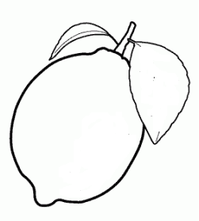

Fig 1. Lemon

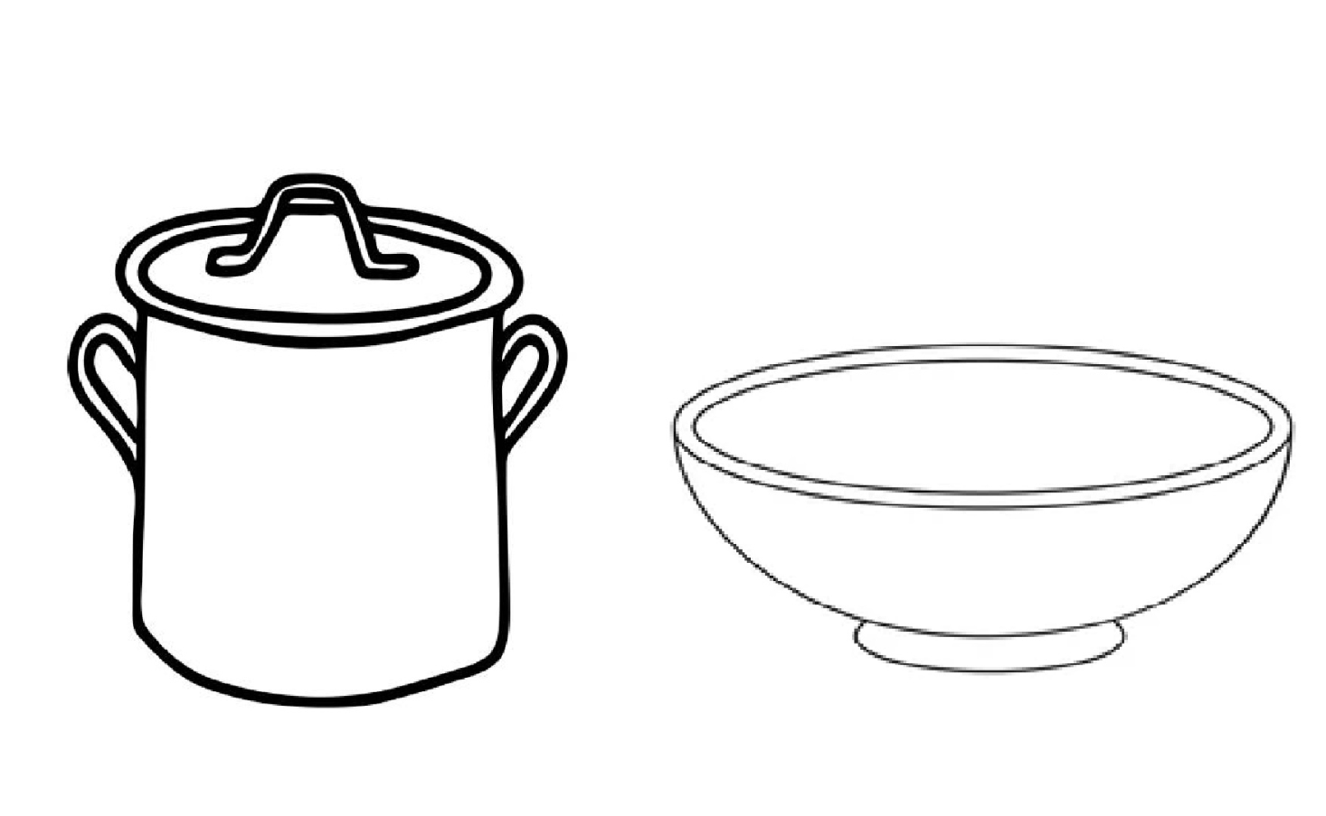

Fig 2. Water Jug and bowl